**Jack’s Birdhouse**

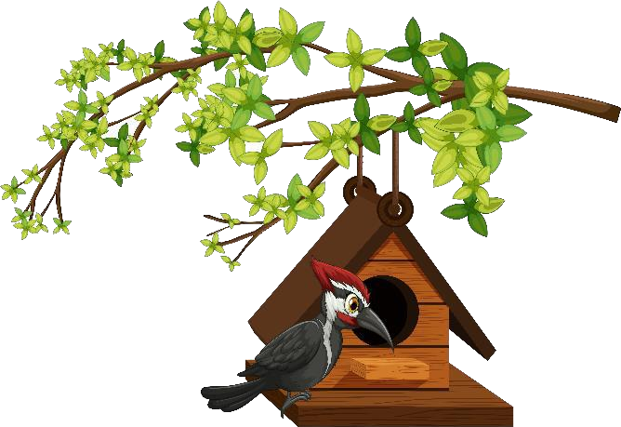Jack wants to build a birdhouse. He gets some wood. He gets some nails and paint. His mom helps too. She gets a saw and a hammer. She gets a pencil and ruler. Jack draws his birdhouse. They build it together. Then they hang it up in a tree. A bird goes into the bird house. A second bird goes in. A third bird goes in. A fourth bird goes in! Jack and his mom look at each other. They need a bigger birdhouse.